Device Energy Monitoring Platform

.Net Core

The goal of the application is to offer users the possibility to overview the energy consumption of their devices, on a daily basis and hourly. A regular user can only see its own devices, while the administrator of the platform can create, update, and delete users, and also map them to new devices.

Architecture of the platform

The application is structured on 3 main layers: Repository Layer, Logic Layer, and Presentation Layer.

Backend

In the repository layer, the connection with the database is established, and data manipulation operations are performed.

The logic layer transforms the data received from the repository layer and sends it to the presentation layer.

On the presentation layer, the controllers are defined, along with the views. The authorization part of the application is handled by Identity, which I have used to manage the claims of the logged in user.

The claims contain the id of the logged in user and its role, used for authorization on the pages.

Frontend

The Frontend of the application is created using HTML and Javascript. The Admin can visualize all the users, create new ones, edit and delete them. It can also map users to devices. A regular user can only visualize its devices and the consumptions, by selecting a day in the calendar.

Admin Pages:

User page

DB Design

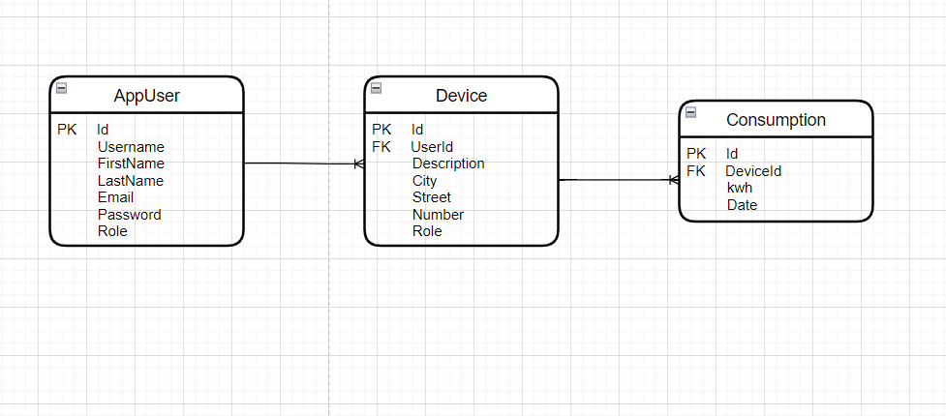

Deployment Diagram

